Camp Directors:
Winfred George (214) 674-9193
Grady Dale (469) 261-2408

CAMP DATES
June 23-25, 2023

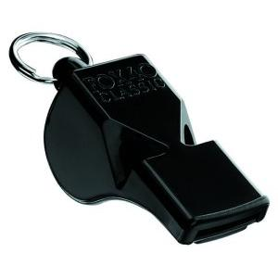
KCBOA
High Level
Officiating

3 Person Evaluation Camp

Scheduled Guests and Clinicians
Top level Officials

This is an excellent opportunity to gain invaluable evaluations and development from highly experienced officials. KCBOA is building a strong foundation on development of officials to help improve officiating in the state of Texas. This camp is held in conjunction with the TABC High School Boys live period session and is designed to help officials develop skills for high level officiating.

KCBOA Evaluation Camp Agenda
JUNE 23, 2023

7:00-7:30 PM Committee/Staff Meeting Location TBD
7:30-7:45 PM Campers Registration Location TBD

JUNE 24-25, 2023 Games/Evaluations Duncanville Area

Tuition: Camp cost $50.00
Please mailed $50 with application and received by May 15, 2023

KCBOA

EVALUATION CAMP

2023

NAME___________________________________________________________________

ADDRESS:________________________________________________________________

CITY: _____________________________STATE____ZIP CODE_______________________

PHONE: _____________________________ EMAIL: _______________________________

CHAPTER AFFILIATION: __________________________

YEARS OF EXPERIENCE: ___________ YEARS OF 3 PERSON EXPERIENCE ______

For more information, please contact:
Winfred E George, winbenzsvc@yahoo.com

I hereby release KCBOA, its staff, all other entities, subsidiaries or partners from any and all liability for any injuries or illness which may occur while at camp. I have no knowledge of any physical disabilities that would affect my participation or performance.
SIGNATURE: ____________________________________________

Please send your $50 by MAY 15, 2023, with application to KCBOA CAMP 1813 Cedar Vista Dr, Mesquite, Tx 75181. Checks payable to KCBOA.

